CC-1

727721EUIT172

1.

CODE:-

package com.Taurus.Ca1;

import org.openqa.selenium.By;

import org.openqa.selenium.WebDriver;

import org.openqa.selenium.chrome.ChromeDriver;

import org.openqa.selenium.chrome.ChromeOptions;

import io.github.bonigarcia.wdm.WebDriverManager;

public class CC_Ques1 {

public static void main(String[] args) throws InterruptedException {

ChromeOptions co=new ChromeOptions();

co.addArguments("--remote-allow-origins=*");

WebDriverManager.*chromedriver*().setup();

WebDriver driver=new ChromeDriver();

driver.get("https://www.saucedemo.com/");

//user login

driver.findElement(By.*xpath*("//*[@id=\"user-name\"]")).click();

driver.findElement(By.*xpath*("//*[@id=\"user-name\"]")).sendKeys("standard_user");

driver.findElement(By.*xpath*("//*[@id=\"password\"]")).click();

driver.findElement(By.*xpath*("//*[@id=\"password\"]")).sendKeys("secret_sauce");

driver.findElement(By.*xpath*("//*[@id=\"login-button\"]")).click();

//Adding to cart

Thread.*sleep*(2000);

driver.findElement(By.*xpath*("//*[@id=\"add-to-cart-sauce-labs-backpack\"]")).click();

String num=driver.findElement(By.*xpath*("//*[@id=\"shopping_cart_container\"]/a/span")).getText();

if(num.equals("1")){

System.***out***.println("Item added to cart");

}

//Viewing cart items

Thread.*sleep*(2000);

driver.findElement(By.*xpath*("//*[@id=\"shopping_cart_container\"]/a")).click();

String act=driver.findElement(By.*xpath*("//*[@id=\"header_container\"]/div[2]/span")).getText();

if(act.equals("Your Cart")) {

System.***out***.println("User can view contents in cart");

}

//checkout

Thread.*sleep*(2000);

driver.findElement(By.*xpath*("//*[@id=\"checkout\"]")).click();

String ac=driver.findElement(By.*xpath*("//*[@id=\"header_container\"]/div[2]/span")).getText();

if(ac.equals("Checkout: Your Information")) {

System.***out***.println("Your information is displayed");

}

//Filling form

driver.findElement(By.*xpath*("//*[@id=\"first-name\"]")).click();

driver.findElement(By.*xpath*("//*[@id=\"first-name\"]")).sendKeys("UMA");

driver.findElement(By.*xpath*("//*[@id=\"last-name\"]")).click();

driver.findElement(By.*xpath*("//*[@id=\"last-name\"]")).sendKeys("SHANKAR");

driver.findElement(By.*xpath*("//*[@id=\"postal-code\"]")).click();

driver.findElement(By.*xpath*("//*[@id=\"postal-code\"]")).sendKeys("635116");

Thread.*sleep*(2000);

driver.findElement(By.*xpath*("//*[@id=\"continue\"]")).click();

String actu=driver.findElement(By.*xpath*("//*[@id=\"header_container\"]/div[2]/span")).getText();

if(actu.equals("Checkout: Overview")) {

System.***out***.println("Overview of the products displayed");

}

//Details of the products

String name=driver.findElement(By.*xpath*("//*[@id=\"item_4_title_link\"]/div")).getText();

System.***out***.println("Name of the product: "+name);

String price=driver.findElement(By.*xpath*("//*[@id=\"checkout_summary_container\"]/div/div[1]/div[3]/div[2]/div[2]/div")).getText();

System.***out***.println("Price of the product: "+price);

//Asserting the title

String actual=driver.getTitle();

if(actual.equals("Swag Labs")) {

System.***out***.println("Title of the page is asserted");

}

//Asserting the url

String a=driver.getCurrentUrl();

if(a.equals("https://www.saucedemo.com/checkout-step-two.html")) {

System.***out***.println("URL of the page asserted");

}

driver.findElement(By.*xpath*("//*[@id=\"finish\"]")).click();

System.***out***.print("Thanks for Ordering!!Come back soon");

}

}

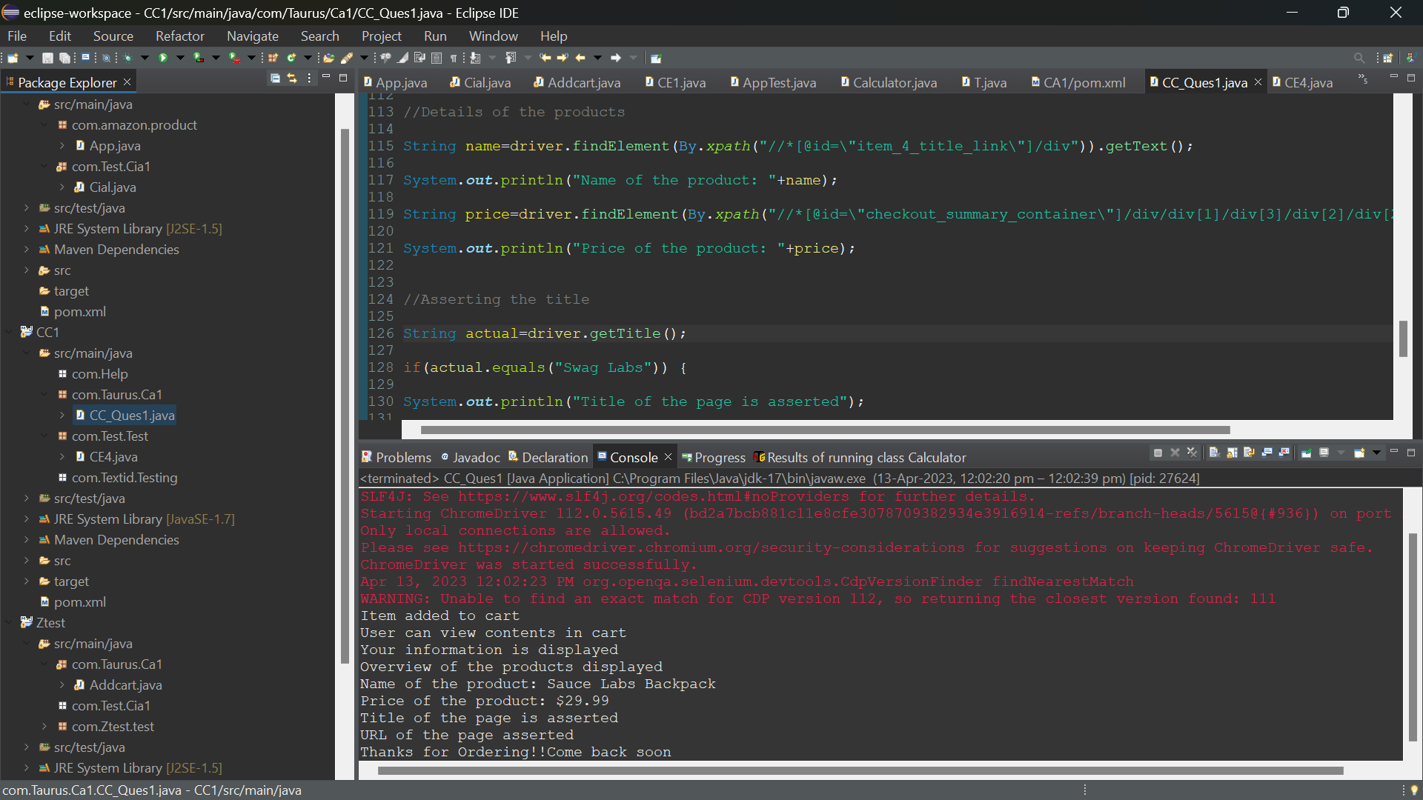

2.

CODE: -

package com.Taurus.Ca1;

import java.util.List;

import org.openqa.selenium.By;

import org.openqa.selenium.JavascriptExecutor;

import org.openqa.selenium.WebDriver;

import org.openqa.selenium.WebElement;

import org.openqa.selenium.chrome.ChromeDriver;

import org.openqa.selenium.firefox.FirefoxDriver;

import org.openqa.selenium.support.ui.Select;

import io.github.bonigarcia.wdm.WebDriverManager;

/**

*

*/

public class Cc_1

{

public static void main( String[] args ) throws InterruptedException

{

WebDriverManager.*chromedriver*().setup();

WebDriver driver = new ChromeDriver();

driver.manage().window().maximize();

driver.navigate().to("https://www.saucedemo.com/");

driver.findElement(By.*xpath*("//*[@id=\"user-name\"]")).sendKeys("standard_user");

driver.findElement(By.*xpath*("//*[@id=\"password\"]")).sendKeys("secret_sauce");

driver.findElement(By.*xpath*("//*[@id=\"login-button\"]")).click();

String title=driver.getTitle();

if(title.equals("Swag Labs")) {

System.***out***.println("Title Matched");

System.***out***.println("Title : "+title);

System.***out***.println("URL : "+driver.getCurrentUrl());

}

else {

System.***out***.println("Title is MisMatched");

}

WebElement b=driver.findElement(By.*xpath*("//*[@id=\"header_container\"]/div[2]/div/span/select/option[1]"));

if(b.getText().equals("Name (A to Z)")) {

System.***out***.println("Filter can be applied from A-Z");

}

else {

System.***out***.println("Filter cannot be applied from A-Z");

}

b=driver.findElement(By.*className*("inventory_item_name"));

System.***out***.println("Product A-Z : "+b.getText());

Thread.*sleep*(3000);

Select se = new Select(driver.findElement(By.*xpath*("//*[@id=\"header_container\"]/div[2]/div/span/select")));

se.selectByValue("za");

b=driver.findElement(By.*xpath*("//*[@id=\"header_container\"]/div[2]/div/span/select/option[2]"));

if(b.getText().equals("Name (Z to A)")) {

System.***out***.println("Filter can be applied from Z-A");

}

else {

System.***out***.println("Filter cannot be applied from Z-A");

}

b=driver.findElement(By.*className*("inventory_item_name"));

System.***out***.println("Product Z-A : "+b.getText());

Thread.*sleep*(3000);

Select se1 = new Select(driver.findElement(By.*xpath*("//*[@id=\"header_container\"]/div[2]/div/span/select")));

se1.selectByValue("lohi");

b=driver.findElement(By.*xpath*("//*[@id=\"header_container\"]/div[2]/div/span/select/option[3]"));

if(b.getText().equals("Price (low to high)")) {

System.***out***.println("Filter can be applied from Low-High");

}

else {

System.***out***.println("Filter cannot be applied from Low-High");

}

b=driver.findElement(By.*className*("inventory_item_name"));

System.***out***.println("Product Low-High : "+b.getText());

Thread.*sleep*(3000);

Select se2 = new Select(driver.findElement(By.*xpath*("//*[@id=\"header_container\"]/div[2]/div/span/select")));

se2.selectByValue("hilo");

b=driver.findElement(By.*xpath*("//*[@id=\"header_container\"]/div[2]/div/span/select/option[4]"));

if(b.getText().equals("Price (high to low)")) {

System.***out***.println("Filter can be applied from High-Low");

}

else {

System.***out***.println("Filter cannot be applied from High-Low");

}

b=driver.findElement(By.*className*("inventory_item_name"));

System.***out***.println("Product High-Low : "+b.getText());

}

}

